2 . Interference by division of amplitude

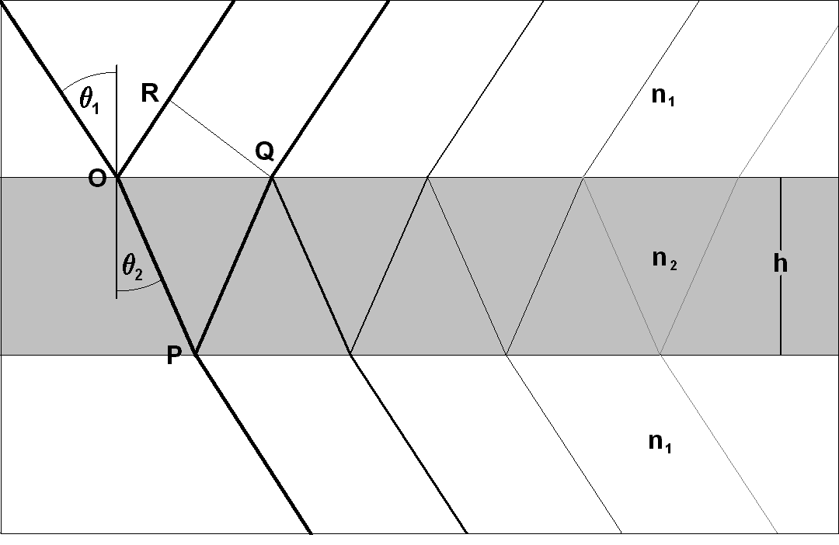
This phenomenon is produced in its pure form if no aperture is limiting the beam. The archetypal case is a plane paralell plate.
Fig. 2.1

Phase difference

In Fig 2.1 the boundaries of the plate are separated by a thickness of material with index 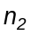, surrounded by a medium of index 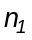. A beam is reflected in the upper face, and other penetrates and is reflected in the lower face, to later emerge through the upper one and interfere with the former.
Part of the emerging beam is reflected again and the phenomenon is repeated with decreasing amplitudes.
The difference of optical path between two contiguous is

(2.1) 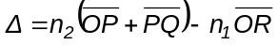

Also is
(2.2) 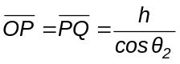

(2.3) 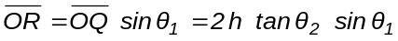

(2.4) 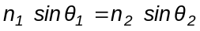

From the last three eqations, follows

(2.5) 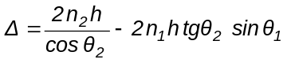

(2.6) 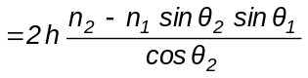

(2.7) 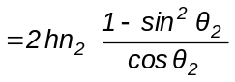

(2.8) 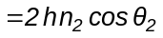

The phase difference is

(2.9) 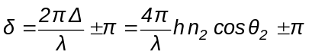

is the vacuum wavelength.
This formula has great importance, it is the key to interpret the phenomena of interference by division of amplitude.
The geometric places from where exits beams with the same phase difference form the interference fringes.
If the fringes are observed by transmission, the expression foris the same except the term . The origin of this term will be seen in eq (2.10)
As depends only on 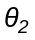, they are called fringes of equal inclination.
If the beam is collimated, ( constant) but the surfaces are not planes, the fringes are lines of equal thickness .
This last setup is useful in the optical shop, for testing optical surfaces.
The topography of the surface to be tested is obtained by comparison with a master surface.

To think.

¿Where come from the colors of soap bubbles, and why there are not seen interference fringes in the glass of a window?
The answer has to be with the thickness, and the collimation and monochromaticity of the light used.

Multiple beam interference

Two beam interference is the first approximation, and the complete phenomenon is described by a geometric series.
It is necesary to introduce a nomenclature for managing the formulas. Let's call
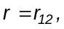 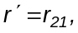 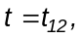 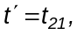 where the indices indicate the media.
It is easy to verify the following relations among Fresnel formulae, also true for oblique incidence:

(2.10) 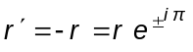 ; 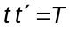 ; 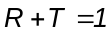

The reflected amplitude is

(2.11)

The transmitted amplitude is

(2.12)

Considering the reflected amplitude

(2.13)

The parenthesis is a geometrical series with ratio 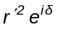. Then
(2.14) 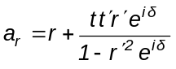

Using relations (2.10), the expression is processed

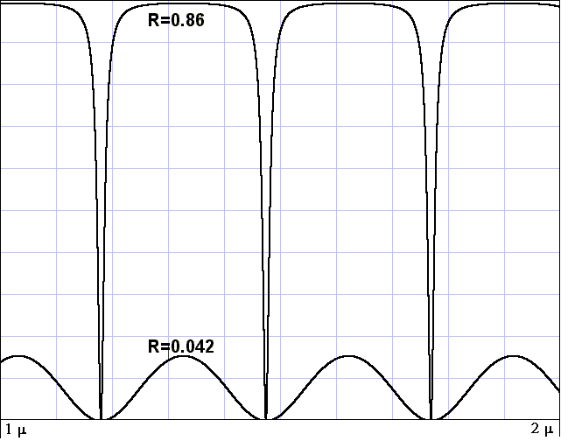
(2.15) 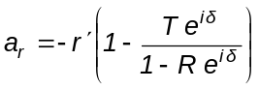

(2.16) 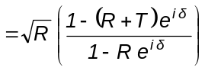

(2.17) 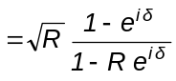

The intensity reflected by the plate is

(2.18) 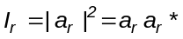

(2.19) 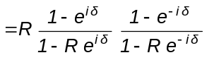
Fig. 2.2
(2.20) 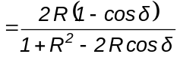
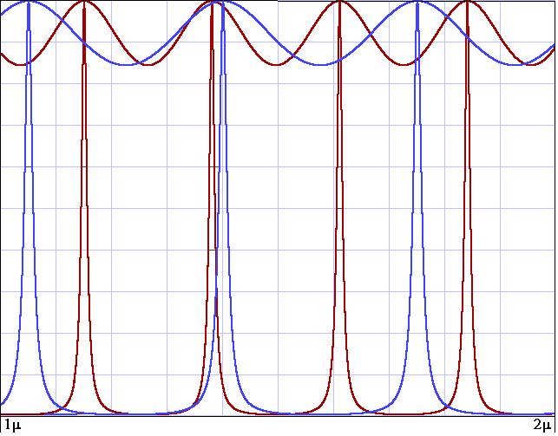
(2.21) 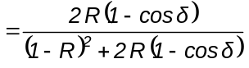

(2.22) 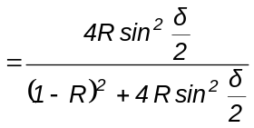

With a similar method it is obtained

(2.23) 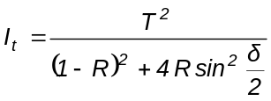

Calling

(2.24) 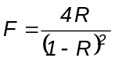
Fig. 2.3

and remembering that follows

(2.25) 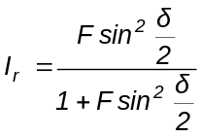

(2.26) 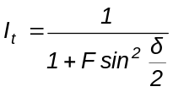

For the entire plate is 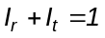and for each face is
In Fig. 2.2 is plotted vs h for 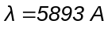 and h varying from 1 to 2 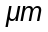.

It is shown a system of fringes with high contrast formed with R = 0.86 and in the lower part one of low contrast formed with R = 0.042

Excercise

Write down a program to generate these figures. Here is one.

Listing FAIRY Compiled FAIRY

Fig 2.3 shows fringe formation for two different.
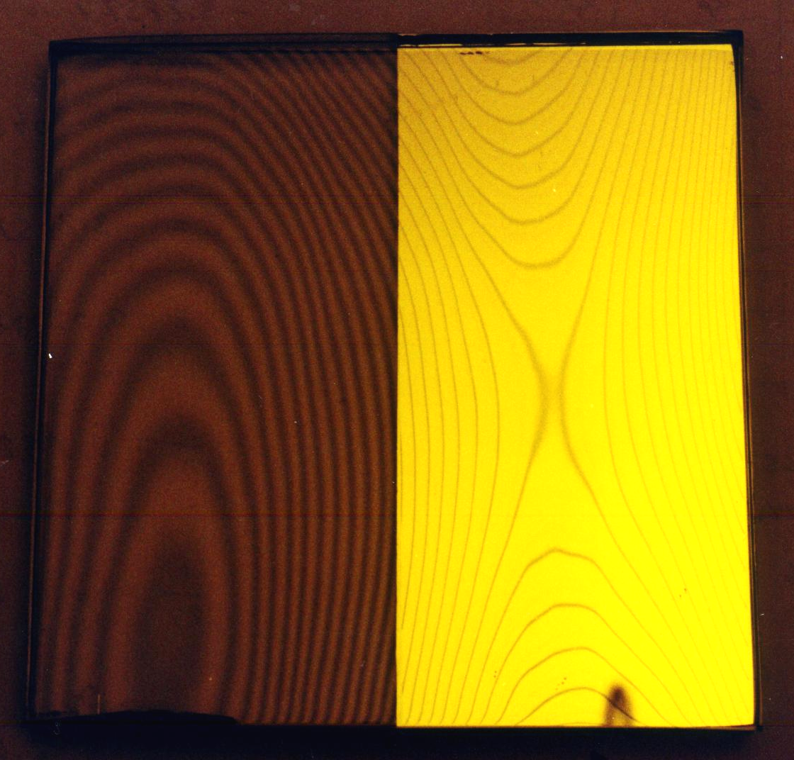
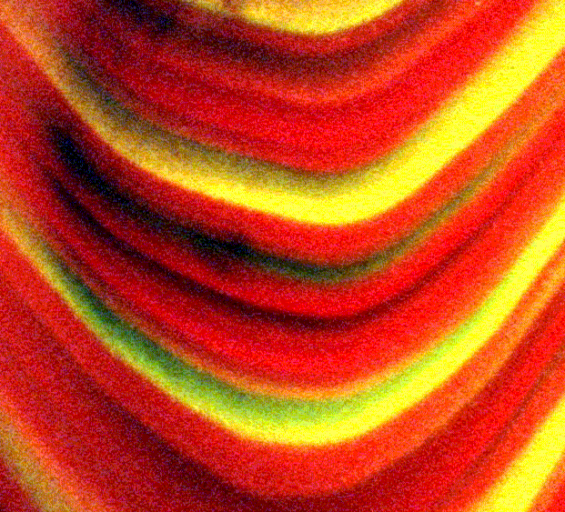
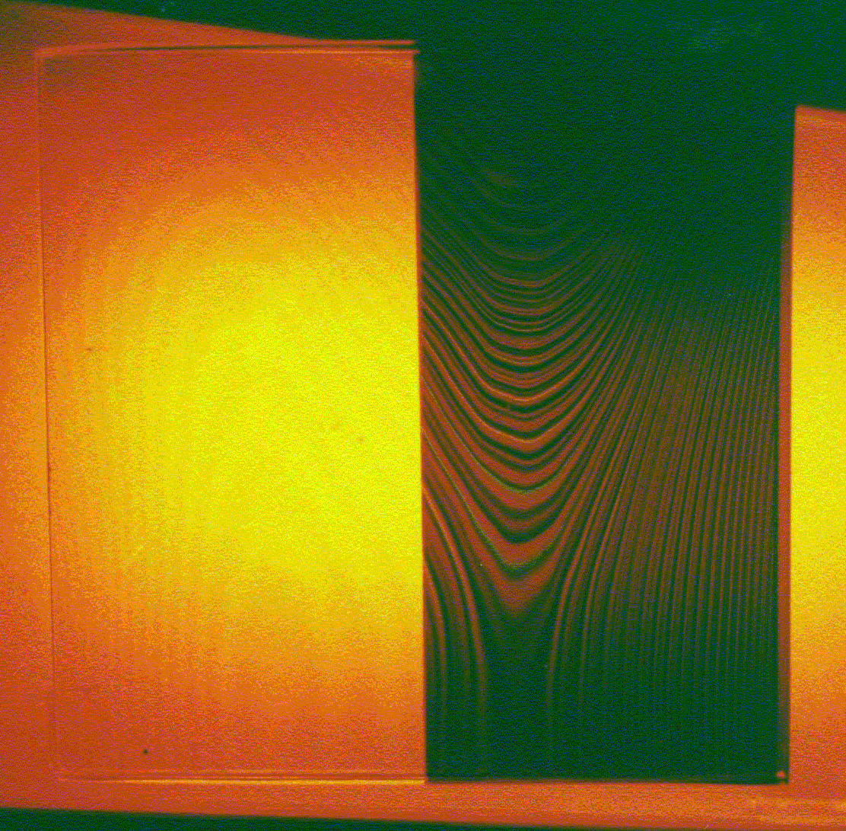

Fig. 2.4
Fig. 2.5

Fig. 2.4 is the photograph of an experimental setup illustrating Fig. 2.2. There has been superposed two glass plates having each one half of its surface coated by a semitransparent film of silver, illuminated with a sodium lamp.

The thickness h is given by the thin sheet of air separating the plates, and it vary from place to place in several microns. Over the silvered part they are seen fine high contrast fringes.

In the same way, Fig. 2.5 illustrates Fig. 2.3. The fringes are observed by transmission and the plates where illuminated by a neon lamp. There are seen fringe systems in various colors in the zone of fine fringes. This setup is the conceptual basis for the Fabry-Perot interferometer.
In order that the fringes to be fine, R must be high. Within this context, R can only rise by rising , but in this way it cannot reach very far because there are no sustances with so high indices. The solution is to coat a mirror on the surfaces. If the mirrors are all dielectric the formula is the same. If they are absorbing (for example silver), is 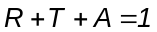. In this case is

(2.27) 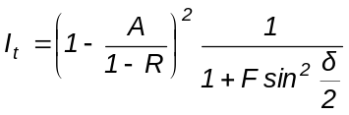

Antireflection coatings

Let's see a problem of great practical importance: to define the thickness h and index n of an antireflection coating on glass to supress Fresnel reflection.
To do this we can put

(2.28) 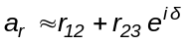

Here there are three different indices and relations (2.10) don't apply but it may be set 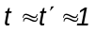 and take just two terms because the reflectivity is low. The minimum for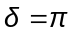 is 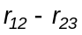.
Hence, if the index of glass and air are 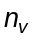 and 1,
(2.29) 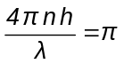 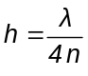
(2.30) 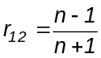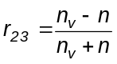 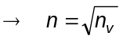

Let be an antirreflecting coating for common glass in = 5500 Å

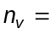1.52 → 1.232 ; 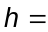1116 Å

The usual material approaching this index with good mechanical properties is magnesium fluoride 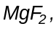with 1.38, and the reflectivity does not vanishes completely.
Is . For comparison, for the glass alone is 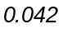
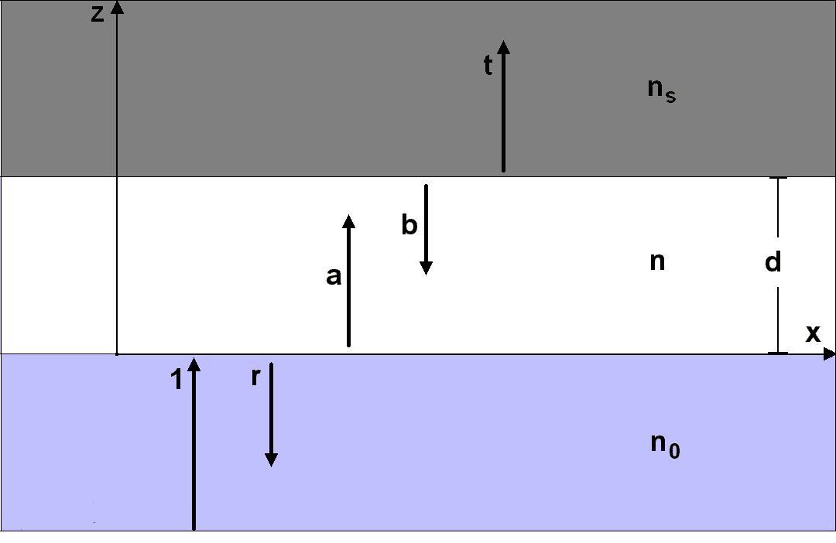
To design a more efficient antirreflectant there are used several layers; each one introduces a complex term in equation (2.28) and the goal is to close the poligonal obtained on summing them.

Abeles-Herpin matrix calculations

We have seen how to calculate the reflectivity and transmissivity of a plate, or of a pile of them if the reflectivity is small
The method of multiple reflections is not applicable to the general case because it is necesary to sum infinite series for each possible path
Applying matrix theory to the fields E and B results in a very simple
Fig 2.6
calculation scheme that solves the problem entirely.
In Fig. 2.6 a wave incides normally on a layer from below with unit amplitude.
There are shown the directions s and the amplitudes of each wave originated from this.
The fields in a plane wave travelling in direction z are
(2.31) 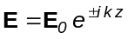 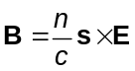
Remember that s is the unit vector seen in equation (1.89)
In what follows it will be omitted the factor c because in the final formulas cancels out.
If the incident wave has unit amplitude, in the first medium ( z ≤ 0 ) is

(2.32) 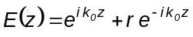 (Let it be the y component of E)

(2.33) 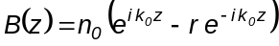 (Let it be the z component of B)

In the expression for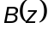, the minus sign of r is due to the vector product with s in opposite direction.
Inside the layer, ( 0 < z < d ),

(2.34) 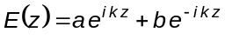

(2.35) 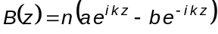

In the second medium, ( z ≥ d )

(2.36) 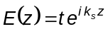

(2.37) 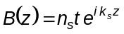

With ( 2.34) and (2.35) are formed the expressions

(2.38) 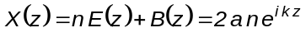

(2.39) 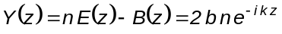

That may be put

(2.40) 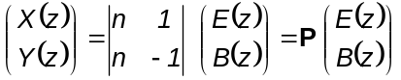

Also
(2.41) 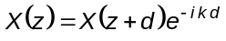

(2.42) 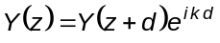

That may be put

(2.43) 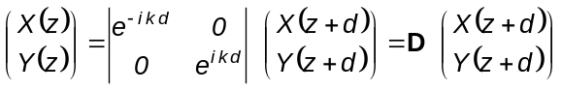

Finally
(2.44) 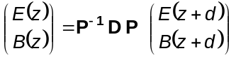

The matrix 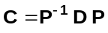 characterizes the layer.

Determination of

The inverse of is (solving the system of two equations with two unknowns)

(2.45) 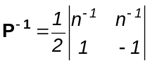

Hence, is
(2.46) 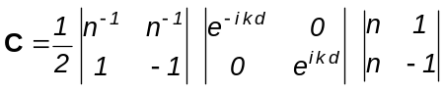

Partial product

(2.47) 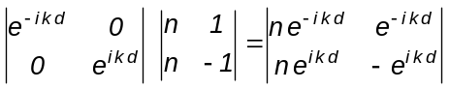

Total product
(2.48) 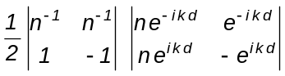

(2.49) 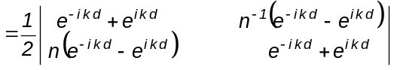

(2.50) 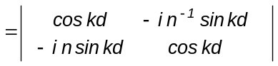

If there are two layers

(2.51) 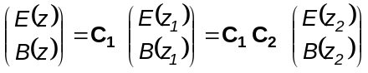

In general the multilayer is characterized by the matrix

(2.52) 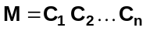

Let's call with sub-index 0 the quantities in the first boundary and with sub-index s those of the last (sustrate)

Is
(2.53) 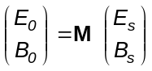

Or
(2.54) 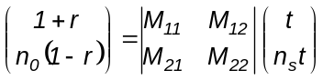

Defining auxiliary quantities A, B,

(2.55) 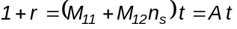

(2.56) 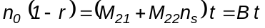

Results
(2.57) 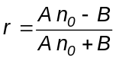

(2.58) 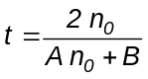

This is a generalization of the Fresnel formulae because if d → 0 in all layers, they vanishes and

(2.59) 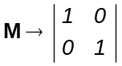

Replacing these values results

(2.60) 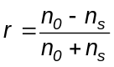
(2.61) 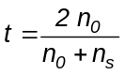

Again the Fresnel formulae for the sustrate alone.
The reflectivity R and transmissivity T are calculated in the same way as in (1.83) y (1.84)

Example

Dielectric mirror of type 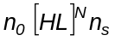.
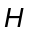means a layer of high index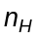and optical thickness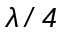. L means a similar layer of low index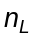. The period 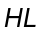is repeated times. For all layers is 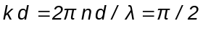.
The matrix of one period is
(2.62) 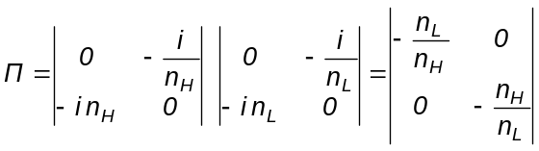

(2.63) 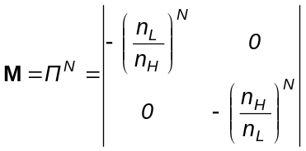

If the first medium is air ( 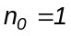), the reflectivity is
(2.64)
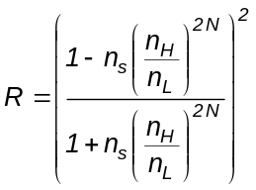

The reflectivity approaches 1 as the number of periods grow.
With usual sustances, 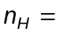2.34 (Zinc Sulphide, 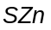), 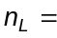1.38 (Magnesium Fluoride, 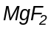), and 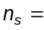1.52 is

N = 1 2 3 4 5 6 7

R = 0.394 0.727 0.895 0.962 0.987 0.995 0.998

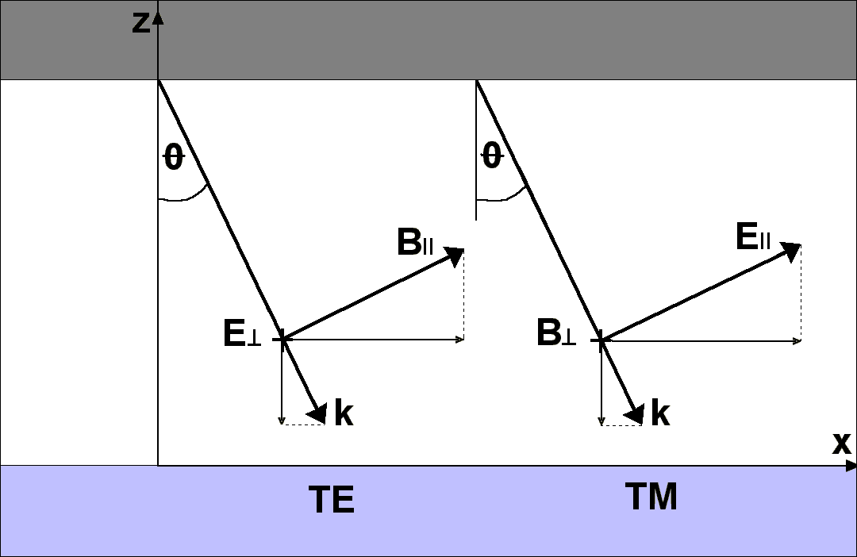
R grows steadily with N, but within a period, on passing from H to L, decreases.
This property is used to monitor the deposition of the multilayer.

Oblique incidence

In equations (2.34) and (2.35) the fields are normal to z and k is paralell. In oblique incidence (Fig. 2.7), the wave can be decomposed in its two basic polarizations TE and TM, and on each one are true these equations for the projections of the field normal to z. For both
Fig 2.7
polarizations is k projected on z
Writing again (2.34) and
(2.35) for the TE wave

(2.65) 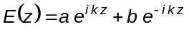

(2.66) 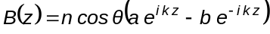

And for the TM wave

(2.67) 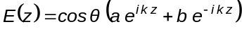

(2.68) 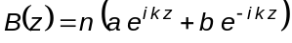

The last pair can be divided by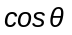and remains valid.
Hence all the mechanism works well if the following replacements are made
(2.69) 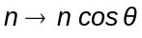 ; 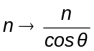

(TE wave) (TM wave)

And
(2.70) 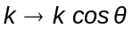 for both

Both polarizations produce different effects and this feature can be used to design a polarizing film.
This theory is not just useful to design and make interference filters (see applications), but also for the investigation of surfaces and stratified media, for example: an oxide layer or paint, the surface of an asteroid or a stellar atmosphere. It may be used too for investigating the polarization appearing in an astronomical instrument when there are surfaces in which light incides obliquely.

